2nd Sunday after Epiphany
CHRIST LUTHERAN CHURCH | Lodi, California
January 21, 2023

WELCOME TO WORSHIP
Welcome to Christ Lutheran Church. We pray that your soul will be strengthened by the good news about God’s grace, love, and forgiveness given to us. If you would like to learn more about our church, please speak with our pastor or one of our members after the service.
- Bathrooms are located in the fellowship hall. A changing table is located in the women’s bathroom.
WORSHIP THEME
Christ calls us to sacrificial discipleship. Peter, Andrew, James, and John left the family business to fish for people. Elisha left his family and farm to heed the call of the prophet. Barnabas and Paul were set apart by God for their missionary journey, which sent them far abroad from the familiar and the safe. Christ may call us to give up comfort, safety, riches, and relationships to follow him. But we gladly go where he leads, because what he gives is of even greater value than anything we lose.
The Service of the Word and Sacrament
The high and holy worship of God is faith in Jesus Christ. Such faith is created and sustained by God’s service to us (the German, “Gottesdienst,” “God/Divine Service). In the Divine Service, the Lord comes to us in His Word and Sacrament to bless and enliven us with His gifts. The Service is not something we do for God, but His service to us received in faith. The liturgy is God’s work. He gives, we receive.
HYMN Come Follow Me, the Savior Spoke| CW 453
INVOCATION
M: The grace of our Lord ✙ Jesus Christ and the love of God and the fellowship of the Holy Spirit be with you.
C: And also with you.
CONFESSION
M: God invites us to come into his presence and worship him with humble and penitent hearts. Therefore, let us acknowledge our sinfulness and ask him to forgive us.
From God’s Word we know that wherever God puts His name, there He is to bless. In the Old Testament the temple was the place where God graciously caused His name to be present (1 Kings 8:27-30).
God has put His name —Father, Son, and Holy Spirit—on us in Holy Baptism. The Divine Service begins with the Invocation, the words spoken over us at our baptisms. Every Divine Service is for the hallowing of the Lord’s name, which the Small Catechism reminds us is done “when the Word of God is taught in its truth and purity, and we, as the children of God, also lead holy lives according to it” (Matthew 28:18-20).
C: Holy and merciful Father, I confess that I am by nature sinful, and that I have disobeyed you in my thoughts, words, and actions. I have done what is evil and failed to do what is good. For this I deserve your punishment both now and in eternity. But I am truly sorry for my sins, and trusting in my Savior Jesus Christ, I pray: Lord, have mercy on me, a sinner.

absolution
M: God, our heavenly Father, has been merciful to us and has given his only Son to be the atoning sacrifice for our sins. Therefore, as a called servant of Christ and by his authority, I forgive you all your sins in the name of the Father and of the Son ✙ and of the Holy Spirit.
C: Amen
LORD, HAVE MERCY - Kyrie
M: For all that we need in life and for the wisdom to use all your gifts with gratitude and joy, hear our prayer, O Lord.
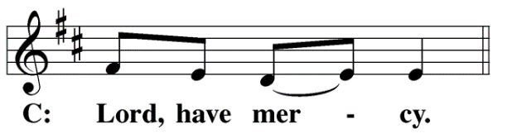
M: For the steadfast assurance that nothing can separate us from your love and for the courage to stand firm against the assaults of Satan and every evil, hear our prayer, O Christ.
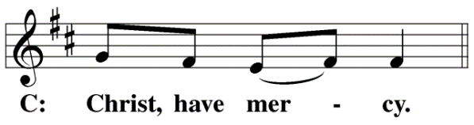

M: For the well-being of your holy Church in all the world and for those who offer here their worship and praise, hear our prayer, O Lord.
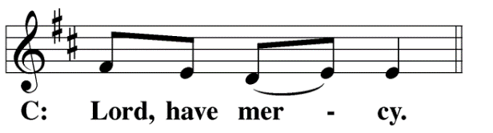
M: Merciful God, maker and preserver of life, uphold us by your power and keep us in your tender care:
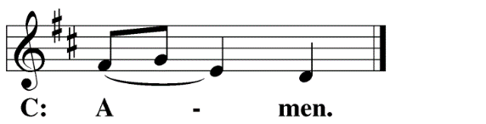
M: The works of the Lord are great and glorious; his name is worthy of praise.
O LORD, OUR LORD
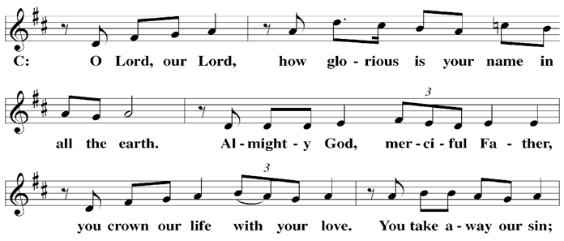

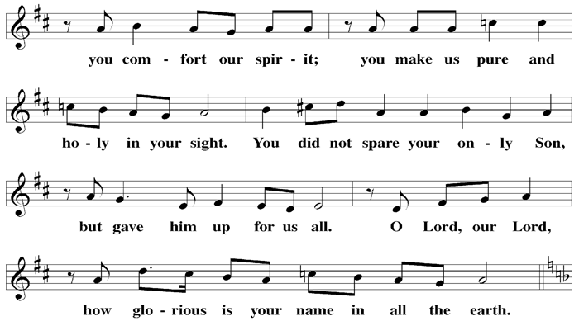

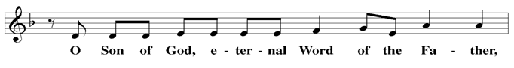

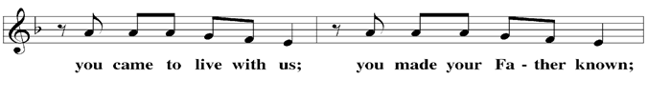

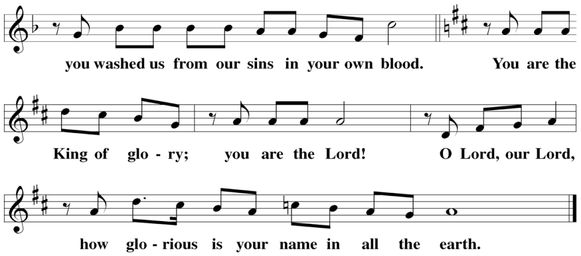

The Service of the Word
Having just received absolution for their sins, believers now gather around the Word of God to find encouragement and peace for their lives on earth.
PRAYER OF THE DAY
M: Let us pray.
Almighty God, you sent your Son to proclaim your kingdom and to teach with authority. Anoint us with the power of your Spirit that we, too, may bring good news to the afflicted, bind up the brokenhearted, and proclaim liberty to the captive; through Jesus Christ, your Son, our Lord, who lives and reigns with you and
the Holy Spirit, one God, now and forever.
C: Amen
FIRST LESSON 1 Kings 19:19–21
Elijah calls Elisha to be his successor as prophet.
¹⁹ So Elijah went from there and found Elisha son of Shaphat. He was plowing with twelve yoke of oxen, and he himself was driving the twelfth pair. Elijah went up to him and threw his cloak around him. ²⁰ Elisha then left his oxen and ran after Elijah. “Let me kiss my father and mother goodbye,” he said, “and then I will come with you.”
“Go back,” Elijah replied. “What have I done to you?”
²¹ So Elisha left him and went back. He took his yoke of oxen and slaughtered them. He burned the plowing equipment to cook the meat and gave it to the people, and they ate. Then he set out to follow Elijah and became his servant.
PSALM Psalm 62, Blue Hymnal
SECOND LESSON Acts 13:1–5
Paul and Barnabas are called to proclaim the gospel to the Gentiles.
3 ¹ Now in the church at Antioch there were prophets and teachers: Barnabas, Simeon called Niger, Lucius of Cyrene, Manaen (who had been brought up with Herod the tetrarch) and Saul. ² While they were worshiping the Lord and fasting, the Holy Spirit said, “Set apart for me Barnabas and Saul for the work to which I have called them.” ³ So after they had fasted and prayed, they placed their hands on them and sent them off.

⁴ The two of them, sent on their way by the Holy Spirit, went down to Seleucia and sailed from there to Cyprus. ⁵ When they arrived at Salamis, they proclaimed the word of God in the Jewish synagogues. John was with them as their helper.
VERSE OF THE DAY Matthew 4:23
Alleluia. Jesus went throughout Galilee, teaching, preaching, and healing every disease. Alleluia.
THE GOSPEL Mark 1:14–20
Jesus calls Peter, Andrew, James and John to follow him and fish for people. They leave their fathers to follow Christ.
⁴ After John was put in prison, Jesus went into Galilee, proclaiming the good news of God. ¹⁵ “The time has come,” he said. “The kingdom of God has come near. Repent and believe the good news!”
¹⁶ As Jesus walked beside the Sea of Galilee, he saw Simon and his brother Andrew casting a net into the lake, for they were fishermen. ¹⁷ “Come, follow me,” Jesus said, “and I will send you out to fish for people.” ¹⁸ At once they left their nets and followed him.
¹⁹ When he had gone a little farther, he saw James son of Zebedee and his brother John in a boat, preparing their nets. ²⁰ Without delay he called them, and they left their father Zebedee in the boat with the hired men and followed him.

M This is the Gospel of the Lord.
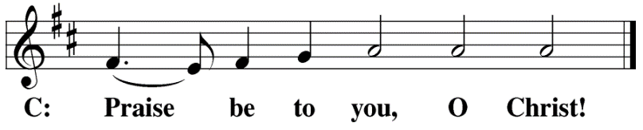

HYMN OF THE DAY O God From God, O Light From Light| CW 85
SERMON 1 Kings 19
NICENE CREED
Having heard the Word of God, we confess our faith in His name. The creed is our saying back to God what He has first said to us. In the Creed we acclaim the truth of the triune God and His work of salvation accomplished for us in His incarnate Son, Jesus Christ.
We believe in one God, Dt. 6:4
the Father, the Almighty, 2 Cor. 6:18
maker of heaven and earth, Is. 51:13
The Nicene Creed is the great Confession of the Christian faith professed by all Christians. The Creed originated at the First Council of Nicaea (c. AD. 325)
of all that is, seen and unseen. Col. 1:16
We believe in one Lord, Jesus Christ, 1 Cor 8:6
the only Son of God, Jn. 3:16
eternally begotten of the Father, Heb. 1:2,5
God from God, Light from Light, true God from true God, Jn. 1
begotten, not made, of one being with the Father. Jn. 10:30
Through him all things were made. Jn. 1:3
For us and for our salvation, 1 Th. 5:9
he came down from heaven, Jn. 6:38
was incarnate of the Holy Spirit and the virgin Mary, Lk. 1:35
The Creed itself was crafted as a confession of Scripture in opposition to the Arian heresy, which denied that the Lord Jesus and the Holy Spirit are God.

and became fully human. Gal. 4:4
For our sake he was crucified under Pontius Pilate. Mk. 15:15
He suffered death and was buried. 1 Cor. 15:3-4a
On the third day he rose again in accordance
with the Scriptures. 1 Cor. 15:4b
He ascended into heaven Ac. 2:33-34
and is seated at the right hand of the Father. Heb. 1:13
He will come again in glory Mt. 25:31
to judge the living and the dead, 2 Tim. 4:1
and his kingdom will have no end. Lk. 1:33
We believe in the Holy Spirit, the Lord, the giver of life, Job 33:4
who proceeds from the Father and the Son, Jn. 15:26
who in unity with the Father and the Son Jn. 4:24
is worshiped and glorified,
who has spoken through the prophets. 2 Pet. 1:25

We believe in one holy Christian Mt. 16:18; Eph. 2:19-20
and apostolic Church.
We acknowledge one baptism for the forgiveness of sins. Eph. 4:5; Ac. 2:38
We look for the resurrection of the dead 1 Cor. 15:21-22
and the life of the world to come. Amen. Rev. 22

OFFERING
In response to God’s love and forgiveness, we give back a portion of what he has given us. The members of Christ Lutheran Church have joined to proclaim the gospel to this community. These offerings support that work. While our guests are welcome to participate, they should not feel obligated to do so.
PRAYER OF THE CHURCH
M: Lord God, heavenly Father, You desire not the death of a sinner but that all would repent and believe the Gospel. In the epiphany of Your Son, Your time of salvation and Your kingdom have come near. As this world passes away, give faithfulness and urgency to Your Church to proclaim the Gospel of our God to all people. Lord, in Your mercy,
C: Hear our prayer.
M: Lord of the harvest, as You called Simon Peter and Andrew, James and John to follow You and made them fishers of men, so send faithful preachers of Your Gospel in our time. Increase the spirit of generosity to all who support our missionaries, seminary, colleges and other institutions of our Church for the spread of the Gospel and the service of God’s people. Lord, in Your mercy,
C: Hear our prayer.
M: Eternal Lord, in view of every current distress as the present form of this world passes away, give constancy and contentment to Your people in their God-given stations. Give comfort and faithfulness to the married, and strengthen them to pass on the faith to the next generation. Show kindness also to the unmarried and assure them of the holiness of their place in life, that they would be freed from anxiety and attend to holiness in body and spirit, undividedly devoted to You. Lord, in Your mercy,
C: Hear our prayer.

M: Almighty God, preserve our nation with its rulers. Call to repentance those who have forgotten You. Spare Joseph, our president; _____________, our governor; and all who serve for the good of this people. Do not let disaster befall us, but preserve us in peace and quietness. Lord, in Your mercy,
C: Hear our prayer.
M: Merciful Father, turn us from every distracting anxiety and the dealings of this world that would draw our hearts away from Your blessed Gospel and its end, eternal life. Give us confidence in the resurrection and the peace of a clean conscience by the forgiveness of sins in Jesus’ name. Graciously behold and help those for whom we pray. Lord, in Your mercy,
C: Hear our prayer.
M: Gracious Lord, in Your Holy Sacrament You deliver the Gospel proclaimed by Your Son and won by His death in His true body and blood. Work repentance and faith in all who come to the table, and unite us in a sincere confession of Your divine truth at this altar. Lord, in Your mercy,
C: Hear our prayer.
M: All these things and whatever else You know that we need, grant us, Father, for the sake of Him who died and rose again and now lives and reigns with You and the Holy Spirit, one God forever.
C: Amen.
LORD’S PRAYER Matthew 6:9-13; Luke 11:2-4
C: Our Father, who art in heaven,
hallowed be thy name,
thy kingdom come,
thy will be done on earth as it is in heaven.
Give us this day our daily bread;
and forgive us our trespasses,
as we forgive those
who trespass against us;
and lead us not into temptation,
but deliver us from evil.
For thine is the kingdom
and the power and the glory
forever and ever. Amen.

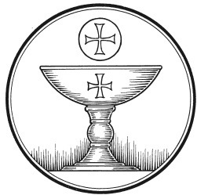
The Service of the Sacrament
This greeting marks a new service, so to speak. These ancient introductory words & phrases help to highlight, celebrate and bring attention to the Sacrament.
M: The Lord be with you.
C: And also with you.
M: Lift up your hearts.
C: We lift them up to the Lord.
M: Let us give thanks to the Lord our God.
C: It is right to give him thanks and praise.
M: Praise to the God and Father of our Lord Jesus Christ! In love he has blessed us with every spiritual blessing. Through his holy prophets, he promised a King to bring light to those living in darkness and in the shadow of death. Now have come the salvation and the power and the kingdom of our God and the authority of his Christ. To him who sits on the throne and to the Lamb be praise and thanks and honor and glory for ever and ever:

HOLY, HOLY, HOLY – Sanctus
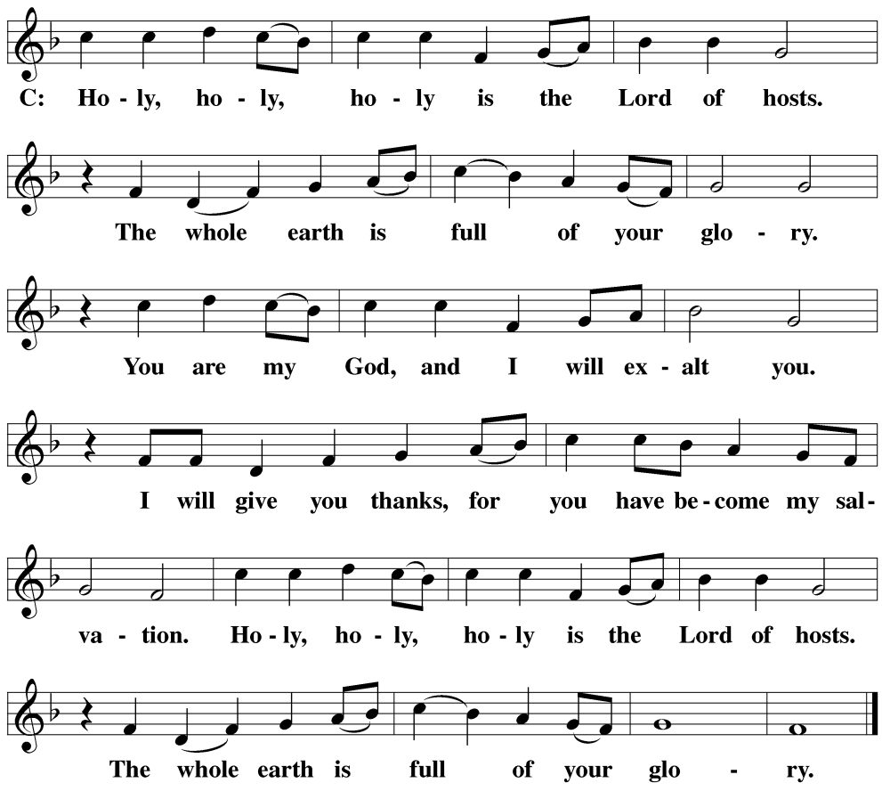

WORDS OF INSTITUTION Matthew 26, Mark 14, Luke 22
M: Our Lord Jesus Christ, on the night he was betrayed, took bread; and when he had given thanks, he broke it and gave it to his disciples, saying: “Take and eat. This is my ✙ body, which is given for you. Do this in remembrance of me.”
The Words of institution both proclaim the words of Jesus to the congregation and sets apart the bread and wine for the Lord’s Supper.
Then he took the cup, gave thanks, and gave it to them, saying, “Drink from it all of you; this is my ✙ blood of the new covenant, which is poured out for you for the forgiveness of sins. Do this, whenever you drink it, in remembrance of me.”

PEACE OF THE LORD – Pax Domini John 20:19
M: The peace of the Lord be with you always.
C: Amen

O CHRIST, LAMB OF GOD – Agnus Dei John 1:29
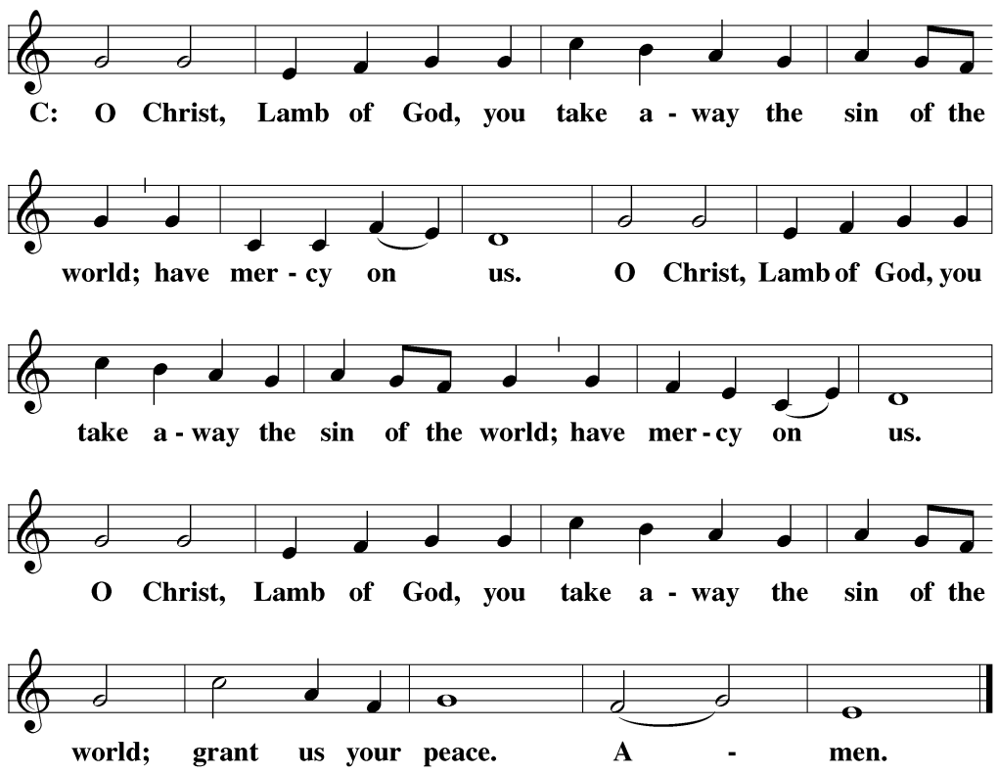
DISTRIBUTION
Those who will be receiving Holy Communion today may wish to read Personal Preparation for Holy Communion, found on page 156 in the front section of the hymnal. This page helps us put into practice what the Bible encourages: “Everyone ought to examine themselves before they eat of the bread and drink from the cup.” (1 Corinthians 11:28)
Christ Lutheran Church confesses and practices the Biblical teaching of a Closed Communion. We ask that only members of the Wisconsin Synod [WELS] or the Evangelical Lutheran Synod [ELS] join us at the Lord’s Table. If you have questions concerning our communion practice, or would like to inquire about how you, too, can commune with us, please speak with the Pastor following the service.

THANK THE LORD
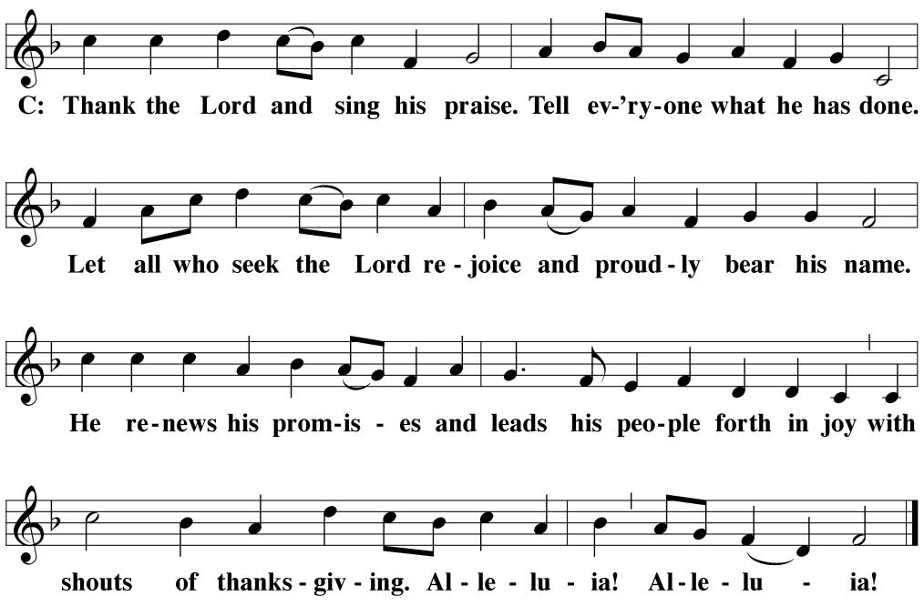
M: Hear the prayer of your people, O Lord, that the lips which have praised you here may glorify you in the world, that the eyes which have seen the coming of your Son may long for his coming again, and that all who have received in his true body and blood the pledge of your forgiveness may be restored to live a new and holy life, through Jesus Christ, our Lord, who lives and reigns with you and the Holy Spirit, one God, now and forever.
C: Amen.

THE BLESSING
M: Brothers and sisters, go in peace. Live in harmony with one another. Serve the Lord with gladness.
The Lord bless you and keep you.
The Lord make his face shine on you and be gracious to you.
The Lord look on you with favor and ✙ give you peace.
C: Amen.
CLOSING HYMN Let Us Ever Walk With Jesus| CW 452

COPYRIGHT INFORMATION
Content requiring a copyright license is reproduced under OneLicense.net #A-718312. All rights reserved. The Common Service: Texts revised from The Lutheran Hymnal, 1941. Music revised by James Engel. Scripture Quotations: From the Holy Bible, New International Version (NIV 1984), © 1973, 1978, 1984 by Biblica, Inc.

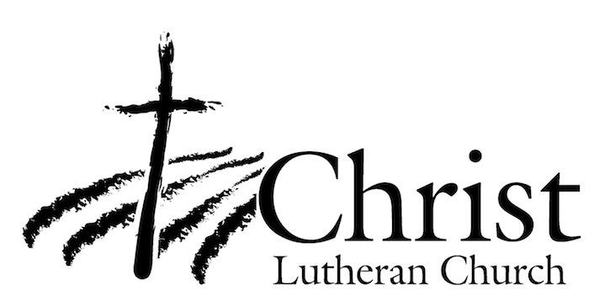
13009 N. Elderberry Ct.
Lodi, CA 95242
www.christlodi.org
209-368-6250
Pastor Joshua Hanson
WELCOME TO CHRIST EV. LUTHERAN CHURCH!
We preach a message of forgiveness, hope and peace
through the death and resurrection of Jesus Christ.
Families and individuals of all ages will find opportunities
both to grow and to serve.
Our mission statement:
Look what Christ is doing!
He binds us together in fellowship
He gathers us in for worship
He builds us up for service
He sends us out with the gospel

“Now you are the body of Christ,
and each one of you is a part of it.”
(1 Corinthians 12:27)

